Entanglement: A Community Art Approach to Environmental Education

Sydney Mantell

Advisors:
Heather Vermeulen
Grant Murray

Coastal Environmental Management Master’s Project
Submitted in partial fulfillment of the requirements for the Master of Environmental Management degree Nicholas School of the Environment, Duke University

Executive Summary

Entanglement was first defined in 1997 by David W. Laist, marine mammal expert and policy analyst, as the ways in which loops and openings of marine debris may entrap an animal. Entanglement has documented effects on 354 distinct species and hundreds of thousands of animals die each year. Still, plastic production continues to increase, and most solutions are short-term and focus on disentangling the small fraction of entangled animals we can see.
But entanglement is connected to more aspects of our existence than the material threat to marine species. In the field of quantum mechanics, two particles are entangled when the state of one is dependent on the other, regardless of how far apart they are. Even if we are separated from our oceans in geographic space, our lives depend on them.
The more my Project progressed, reflecting on entanglement, the more elaborate the meaning of the term became. This complexity is inherent – entanglement is “a means of entangling; that by which a person or thing is entangled; an embarrassment, a snare; a circumstance which complicates or confuses a matter.” My Project aimed to explore these definitions, along with the ways in which our identities are entangled with our daily lives and professions. The academic sciences are especially in need of the practice, as researchers may attempt to remain objective, a characteristic of white supremacy.
Alexis Pauline Gumbs is a fellow Black, Queer woman who knows about entanglement. Her book Undrowned: Black Feminist Lessons from Marine Mammals (2021), changed my perspective on my role as a marine scientist. I should not be learning about marine species. Instead, I should be learning from them. Reading Undrowned’s meditations on themes such as slowing down, collaborating, refusing, resting, and staying Black gave me space to reflect on how I could use art as a form of Community-Based Environmental Management (CBEM).
Within my graduate studies, there were few opportunities for creative engagement like the critical work that Gumbs practices. To me, environmental management should make connections between the social and natural sciences, arts, policy, humanities, and non-western schools of thought instead of relying on one or two. To address this gap, I formulated two main objectives for my MP: To intentionally create spaces for artistic expression in my community, and 2) To collaboratively communicate the concept of entanglement through artwork. I hypothesized that if I could create these spaces for collaborative artmaking and share those works with others, then people may be inspired to continue creating and reflecting on entanglement.
Part of my methodology for my MP involves my own creative practice of fluid painting, a technique I learned alongside my mother Susan. The method involves thinning down acrylic paints then layering all the colors into one cup. Then the paint is plopped, drizzled, or poured onto a canvas, creating unpredictable pieces of art. Just as I had to accept and appreciate the fluidity of my paintings, I had to do the same with my Project as it evolved over the school year. I welcomed the serendipitous connections that informed how I would accomplish my objectives, like my reintroduction to the practice of zinemaking in my Critical Marine Studies class.
Zines, pronounced like “teens,” are interdisciplinary, non-professional, and non-commercial publications that often uplift marginalized voices that are undervalued by mainstream media. With roots in Black feminism and anti-establishment movements of the 1960s and 1970s, zines were used by activists to spark collective action and call attention to issues of environmental injustice. As I learned more about the history and culture associated with zines, I saw the potential in creating a zine for my Project to foster creativity, share perspectives, and reckon with entanglement.
But my project is more about the process, the “means of entangling,” than it is about any final deliverable. Entanglement: A Community Art Approach to Education is two-part project, as I developed and hosted Community Co-Creation Events and compiled the attendees’ artwork along with other independent submissions into Entanglement: A Co-Created Community Zine. The Community Co-Creation Events brought people together to make art, challenge our ways of thinking, strengthen interpersonal connections, and meditate on entanglement. For example, in “Doodle & Discuss: Crafting Against Capitalism,” participants paired doodle artmaking with a guided reading discussion of Gumbs’s “end capitalism” meditation that explicitly discusses the threat of marine entanglement to the North Atlantic right whale. While the “products” of the event, the doodles, are included in my zine, the significance of having that space for reflection cannot be fully encapsulated on a page.
The Entanglement zine contained submissions from over 30 contributors making more than 20 distinct types of media. I plan to continue the recursive process of zinemaking, creating and adding new pieces to the online blog where the zine will be hosted. Other artists have committed to continue creating and reflecting, as well. For example, my mother, Susan, who has made over 140 collages since my “Collaging & Connecting” Community Co-Creation event in November to the publication of this Report in April.
Throughout my MP, I was able to consider our entanglements to oppressive systems, our identities, our communities, and the nonhuman world by collaborating with others. In conclusion, Entanglement: A Community Art Approach to Environmental Education demonstrates ways in which artmaking can build community and encourage deep, recursive learning.

I started this Mammal Project (MP) entangled – my deep love for dolphins inspired by colorful Lisa Frank stickers entangled with my identity as a Queer Black woman in the marine sciences. While this project is deeply personal to me, it is not My Project and I have not “mastered” anything. Nor do I want to. The more I considered entanglement, the more twisted seemingly-familiar concepts became. I had to lean into the fluidity of the process, revising my goals, questions, and methods as the Project evolved. My MP is about that – the process – not only its “deliverables.” The process involved collaborating and resisting and slowing down and listening and staying Black.

Introduction – my life history.

I grew up in Cincinnati, Ohio, hundreds of miles away from the nearest ocean. I couldn’t foster my passion for marine science by getting my feet wet in a tide pool. Instead, I became infatuated with marine life by searching Google and watching Finding Nemo. Throughout my childhood, I made artwork that was inspired by the ocean, from dolphin doodles to school art projects with reef fish to octopus stained-glass mosaics.
Despite making it to the coastal state of North Carolina for undergrad (I’m a proud Tar Heel), I found myself back in landlocked Cincinnati during the COVID-19 pandemic. My mother, Susan, and I spent countless hours making fluid paintings (Figure 1). Also known as pour painting, acrylic pours, and fluid art, this form of painting incorporates the perfect amount of chaos. Acrylic paints are thinned down using a pouring medium and each color is layered into one cup. Then it’s time to pour out the colors deliberately or randomly, in twists, plops, drizzles, and squiggles. Once your paint is on the canvas, you tip or spin the canvas to get the paint to spread to each corner. This is usually where my hands get messy if they aren’t already. Since starting my fluid painting journey, I have learned that you can go into a fluid painting with a plan, but you never really know how it will end up. The finished painting depends on several variables, such as the amount of water you use, the temperature of the room, and the levelness of your drying surface. It’s not hard to be inspired by the ocean when fluidity is inherently part of the practice.
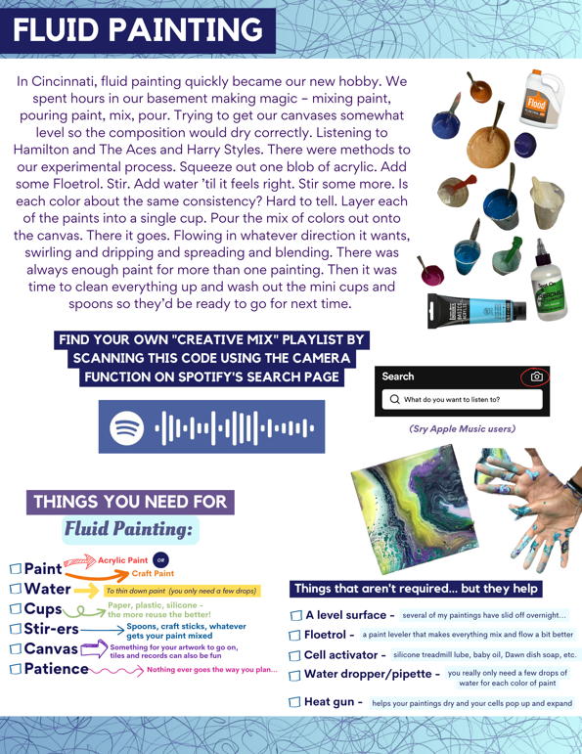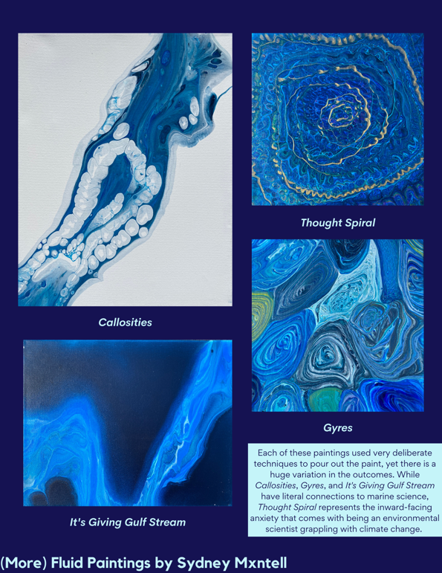
Figure 1. A sample of pages from “Entanglement: A Co-Created Community Zine” that showcase my fluid painting practice.

I returned to this artform during Winter Break 2022-2023, a time when my Project was still in flux. I knew that I wanted to use art as a form of environmental education, but I had not solidified the specifics. I began to see my paintings as a metaphor for my Project. I had a vision for a painting in mind, but I wasn’t sure what pouring technique to use. My Project had to embrace that fluidity because I could not anticipate how people would critically and artistically engage with this work.
During the fall 2022 semester, I was introduced to Undrowned: Black Feminist Lessons from Marine Mammals (2021), by Alexis Pauline Gumbs, during Heather Vermeulen’s Critical Marine Studies class. The book was life-changing for me, as Gumbs, a fellow Queer, Black, artist, and activist, offers a perspective that is often missing from my current environmental management education. In Undrowned, Gumbs writes about her confrontation with the “violent colonizing language” (p. 7) present in our scientific guidebooks and research papers, such as “vagrant juveniles” (p. 6) and how that led her to begin a “Marine Mammal Apprenticeship.” One goal of her Apprenticeship is to practice, share, and encourage a shift from identification as “the process through which we say what is what, like which dolphin is that over there and what are its properties, to identification, that process through which we expand our empathy and the boundaries of who we are become more fluid, because we identify with the experience of someone different, maybe someone of a whole different so-called species” (p. 8, emphasis in original). The meditations Gumbs shares in Undrowned show what we can learn from marine mammals when we “rethink and refeel our own relations, possibilities, and practices” inspired by those of advanced marine mammal life (p.9).
My identity is intertwined with my past, present, and future academic and professional experiences, like the time I was selected to be the DEI (diversity, equity, and inclusion) 4/28/23 2:35:00 PM or when I felt like an outsider at a conference for people who are supposed to be “just like me.” I am only able to afford this graduate program because I have been identified as an underrepresented minority in the sciences, qualifying me for the full ride scholarship from the United Negro College Fund and Bill and Melinda Gates Foundation that has funded my academic career.
As a MEM, I have pursued an interdisciplinary approach to learning about the marine sciences. In addition to taking Critical Marine Studies, I took Inclusion, Diversity, Equity, and Anti-Racism (IDEA) in Biology, a small, seminar-style course that explored the history and persistence of oppression in the biological sciences. I also participated in a travel course to Kino Bay, Mexico this spring. The course focused on learning community-based environmental management (CBEM) practices from the Comcáac indigenous community and small-scale fishers in the area (Figure 2). These classes emphasized the value of alternative forms of knowledge production, including visual, performing, and literary arts, place-based knowledge, and local and indigenous ecological knowledge. I took several other courses that also emphasized CBEM, learning about concepts such community organizing, trust-building, power dynamics, and environmental education.
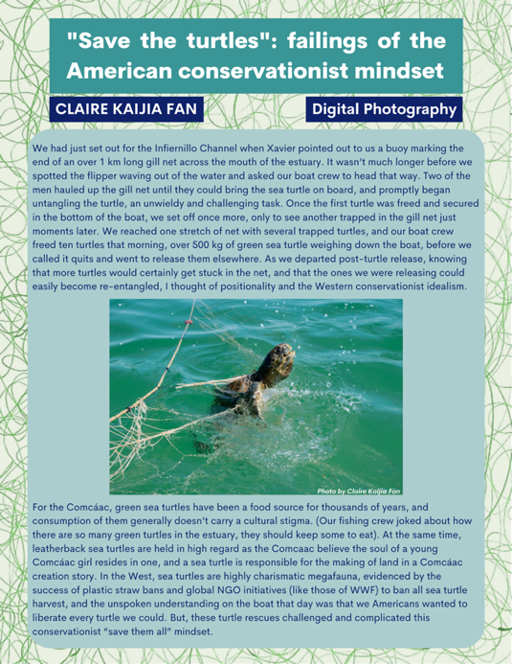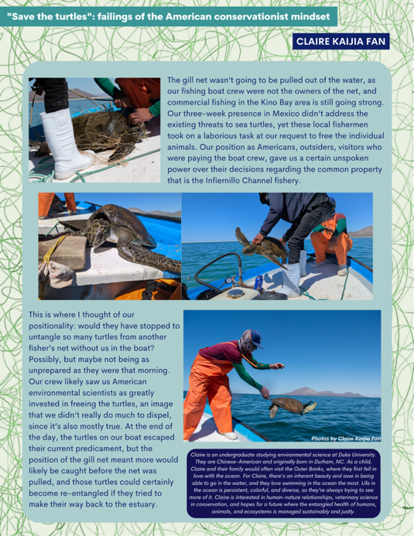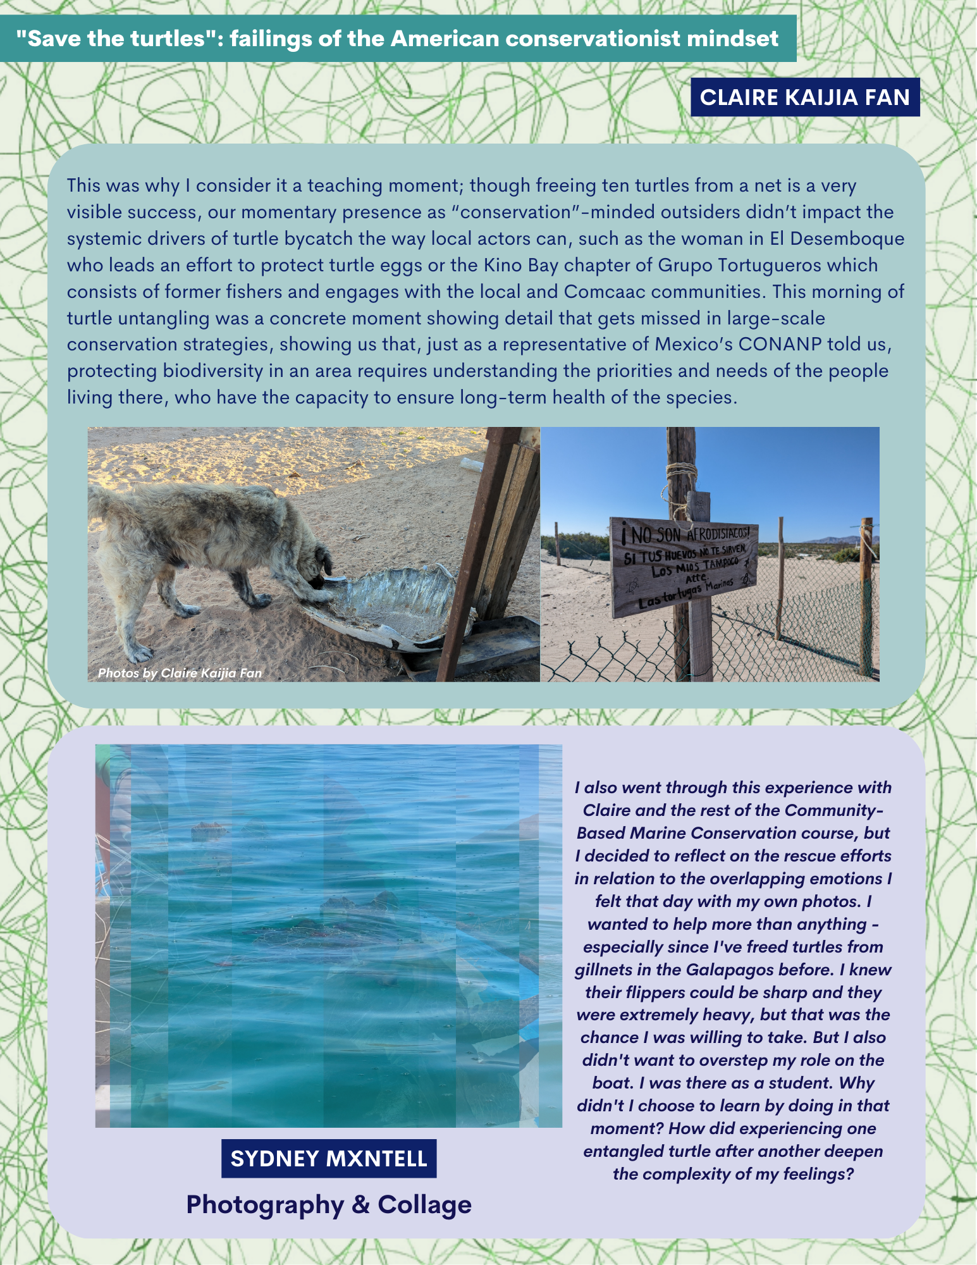
Figure 2. Creative reflections on entangled sea turtles that we encountered during the Community-Based Marine Conservation class in Kino, Bay Mexico by Claire Kaijia Fan and Sydney Mantell.
Research Questions – that will mostly remain unanswered.
What is entanglement?

My Mammal Project addresses the material threat of entanglement. First defined by David W. Laist in 1997, entanglement is the way in which a loop or opening of marine debris can entrap an animal. Entanglement has documented effects on 354 distinct species and hundreds of thousands of animals die each year, including 300,000 whales, dolphins, and porpoises. For each whale that is reported to be entangled, ten more go unreported. Entanglement causes a slow and horrific death for these species, yet plastic production continues to increase, and short-term, small-scale solutions are prioritized. For example, disentanglement teams may risk their lives to remove fishing gear and other marine debris from an individual whale. We only witness a small fraction of the animals that are impacted to marine entanglement, though, as for each whale that is reported to be entangled, there are ten more that go unreported (Figure 3).
Entanglement reaches further than the material threat marine species face. For example, in the field of quantum mechanics, two particles are entangled when the state of one is dependent on the other, regardless of how far apart they are.
The more my Project progressed, reflecting on entanglement, the more elaborate the meaning of the term became. This complexity is inherent to the word itself – entanglement is “a means of entangling; that by which a person or thing is entangled; an embarrassment, a snare; a circumstance which complicates or confuses a matter.” As Figure 3 begins to describe, my Project aimed to explore these definitions, along with the ways in which our identities are entangled with our daily lives and professions. The academic sciences are especially in need of the practice, as the field attempts to remain objective, a characteristic of white supremacy.
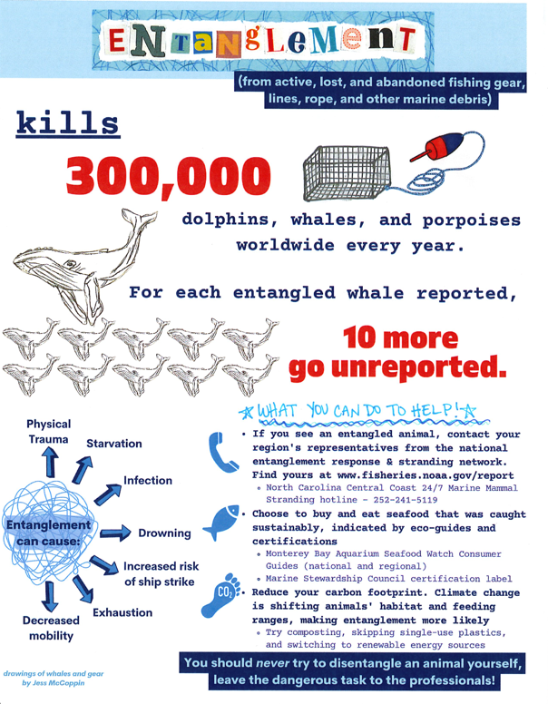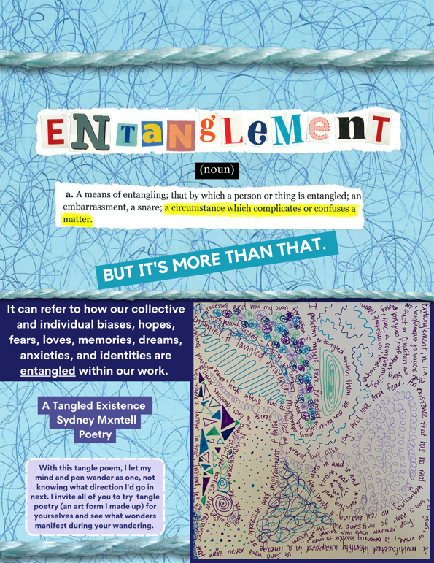
Figure 3. Some of the ways entanglement is described in my zine, including information on marine entanglement from the Marine Mammal Center and one definition of entanglement from the Oxford English Dictionary. The page on the right also features my tangle poem “A Tangled Existence”

How can my MP resist the neoliberal structure of the University?

bell hooks, a groundbreaking Black-feminist author and educator whose work largely centers race, gender, class, and social justice, has argued that education should confront unequal power dynamics and learners should develop a sense of critical consciousness. Science is not objective; it is more than the pursuit of knowledge. When scientists attempt to remove themselves, along with their biases, from their work, they are ignoring the legacies of white supremacy that persist today.
The neoliberal university perpetuates capitalism through western cultural elitism and reducing students, faculty, and staff to human capital. The ideal subject of the neoliberal university is white, male, heterosexual, middle-class, and able-bodied. Relatedly, these institutions have a disregard for care and creatives and place overwhelming demands on time for the people within them.
Sara Ahmed, a British-Australian scholar in the fields of queer theory, feminist theory, and critical race theory, questions how we can make DEI work institutionalized. This would mean that practices and policies that support marginalized groups would become so routine or ordinary that it would become woven in the institution itself. My MP could be part of the process of institutionalizing creative, critical work at the Marine Lab. Those of us who are not welcomed or fully supported by the academy must create our own spaces. I had to create those spaces.

Hypothesis – more like a manifestation.

On a personal level, I wanted to address the need for more creative, critical reflection within my academic experience. I knew that I could not tease apart these concepts alone, though, and collaboration is a fundamental part of any CBEM initiative, Black-feminist project, or Marine Mammal Apprenticeship. I also hoped my peers would benefit from a type of deep, contemplative learning alongside our traditional courses. I wanted to make art and build community while engaging with the complexity of entanglement. If I could establish spaces for collaborative artmaking and share those works with others, then people would be inspired to continue creating and reflecting on entanglement.

Methods – it’s all about the process.

My Mammal Project is recursive. Instead of developing a clear procedure to accomplish a goal and have results, my MP moved in a nonlinear fashion, returning to questions, art pieces, and ruminations. I also had to embrace new ideas, questions, foundational texts, and real time examples of entanglement as they came up. My MP incorporates two main methods to answer my research questions and “test” my hypothesis: Community Co-Creation Events and Entanglement: A Co-Created Community Zine (Figure 4).

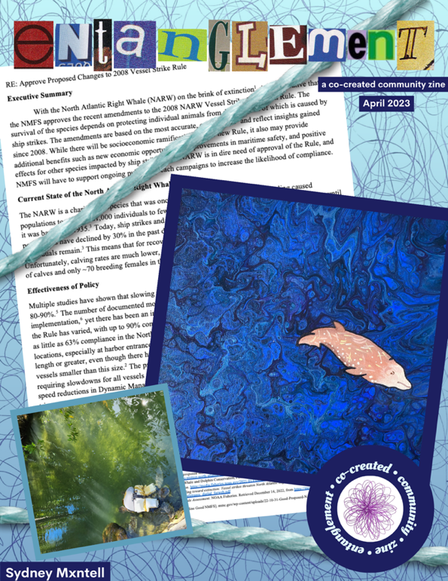
Figure 4. Cover page of Entanglement: A Co-Created Community Zine

Over the course of several months, I developed and hosted Community Co-Creation Events that brought together Marine Lab students, staff, faculty, and friends to make art, challenge our ways of thinking, strengthen connections, and meditate on entanglement. I called on my connections with existing student groups such as the Duke Environmental Justice Network (DEJN), Eno Magazine, the Environmental Communications, Outreach, and Education (ECOE) Club, and Nicholas Queer Network (NQN) to partner with me in hosting these events. These collaborations strengthened my network of support for my MP while advancing club missions, as well. I organized three types of events as a part of my MP, Collaging & Connecting, Doodle & Discuss, and a zinemaking workshop. These events invited participants to think critically about entanglement through artistic media.
My Critical Marine Studies class is where I discovered Undrowned and became refamiliarized with the creative medium of zines. Zines, (pronounced like “teens”) are non-commercial, DIY, interdisciplinary publications that often uplift marginalized voices that may not be valued by mainstream media. Some zines reflect on a certain theme or topic by using a combination of drawings, poetry, collage, narrative, photography, and other artistic media. Zinemaking invites creators and contributors to share unfiltered viewpoints that they might not publish otherwise.
Zines have the potential to empower communities to make a change in their local environment and activate social movements. In the 1960s and 1970s, zines played a crucial role in the anti-establishment and feminist movements in the United States and United Kingdom, creating an intellectual space outside of mainstream scholarship. More recently, zines have been used as community archives to promote environmental stewardship and to discuss environmental justice issues. From 1990 to 2018, there was 1700% increase in zine scholarship.
As a feminist practice, zines strengthen critical thinking skills and create participatory learning by validating personal experience as valid sources of knowledge production. In classroom settings, zines have also been used to improve students’ research and science communication skills. Zinemaking and presenting may be a useful way for students to disseminate information, provide feedback to their peers, and participate in science outreach. This process provides much deeper reflection and learning than the traditional pre- and post-test model that requires students to recall and recite information.
Distributing zines is a horizontal process and circumvents the structures of a neoliberal university. Readers develop personal relationships with the creators as they learn from the content, creating a community. This community of zinesters and zine recipients requires trust and is grounded in values and practices such as respecting personal experiences as sources of knowledge, equality, active listening, the gift economy, and non-professionalism. The boundaries and norms between zine producers and consumers are intentionally blurred.
In practice, working horizontally meant finding contributors to Entanglement by sending email blasts, inviting specific creative people I know, and posting on my social media profiles (Figure 5). During the submission process, artists were also invited to share a short artist statement and optional biography to be included in the zine to engage their work further and strengthen the bond between the person who created the art and those who enjoy it.
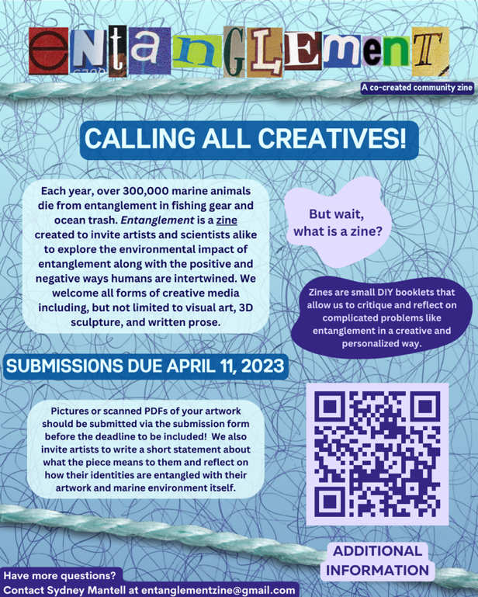
Figure 5. The flyer circulated to collect submissions for Entanglement.

Results
Community Co-Creation Events

There were three types of Community Co-Creation events that used artmaking and critical reflection to educate participants on the varying definitions of entanglement. The events brought together students, faculty, and staff from different subsections of the institution along with a few community members who are unaffiliated with the Marine Lab. “Collaging & Connecting” was the first event, where participants convened to explore the artform of collage, one that was new to many of the attendees. The loosely structured crafting time made space for conversation and relationship-building.
Many of the attendees chose to make a collage that reflected aspects of their own identities (Figure 6).
In “Doodle & Discuss: Crafting Against Capitalism,” I paired a guided reading discussion of Undrowned’s “end capitalism” meditation with doodle artmaking (Figure 7). The tandem activity of drawing and deliberating encouraged participants to open themselves up creatively and intellectually. One participant commented, “It was great to pair art with such a critical conversation. The doodling kept me focused and calm” (Doodle & Discuss Anonymous Feedback Form). By choosing this meditation, I did not shy away from Gumbs’s honest and somewhat jarring reflection of how capitalism is killing humans and our marine mammal family. She wonders “if we could outgrow rope. Braided with blood, a tangled legacy. Could we at this point, evolve past nets of capture, the intersecting technology of getting and keeping” (p.102). She entangles the urgency of the situation, as the North Atlantic right whale (NARW) is on the brink of extinction. Two NAWR aerial observers joined us for the conversation and shared their first-hand knowledge of how they are watching entanglement and ship strikes, two consequences of capitalism, make a species disappear.

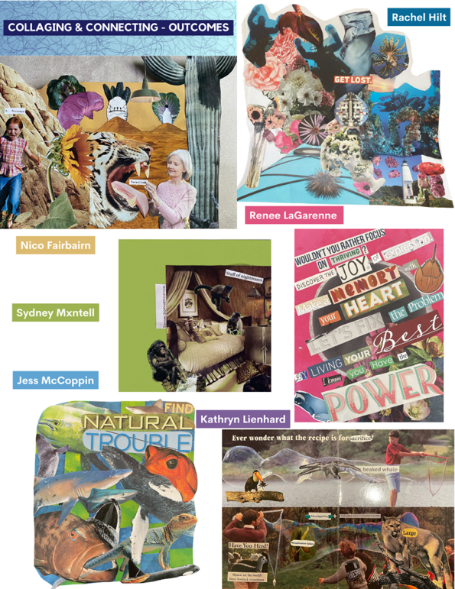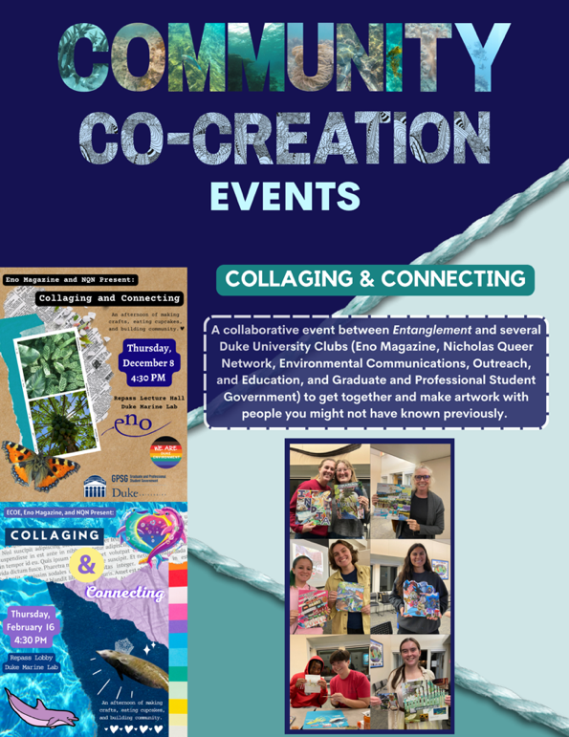
Figure 6. Zine pages that display the artwork created at the Collaging & Connecting event.

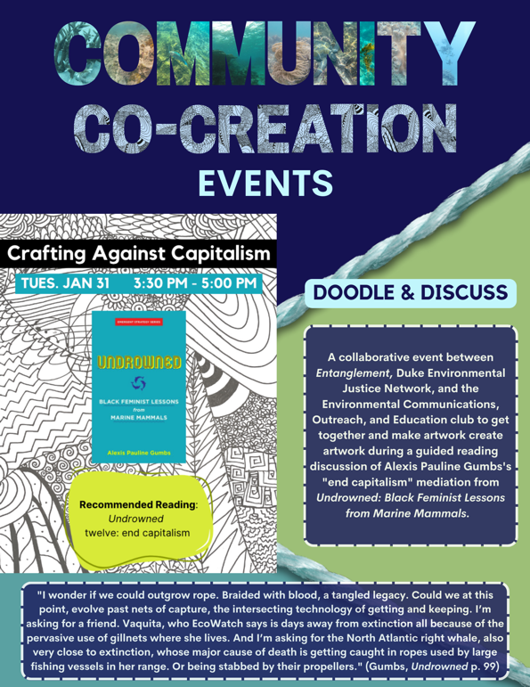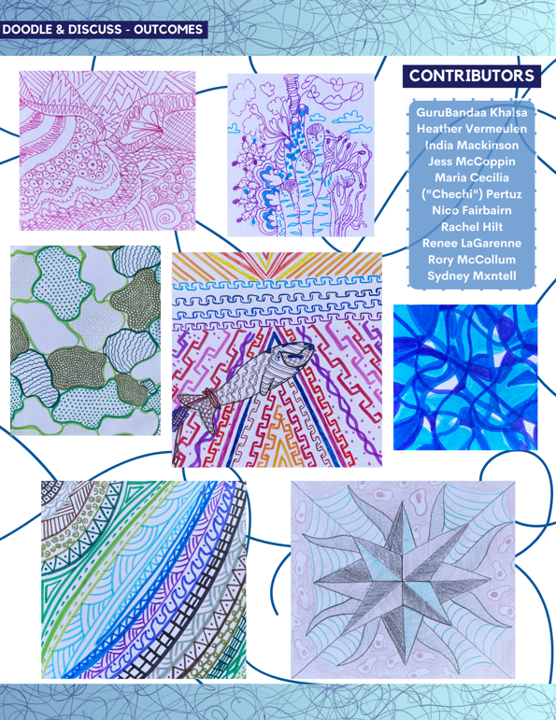
Figure 7. Zine pages that share the goals and creative outcomes of the Doodle & Discuss event.

The final Community-Co Creation event at DUML was a Zinemaking Workshop where community members were invited to create a zine that described how their own lives and backgrounds manifested into their environmental work. Because of the slow nature of zinemaking, no one was able to finish their DIY-booklet during the session. I didn’t finish my “mini meta zine” (Figure 8) about the Entanglement MP until two and a half months later. Returning to the zine reminded me of the reciprocal nature of my MP.

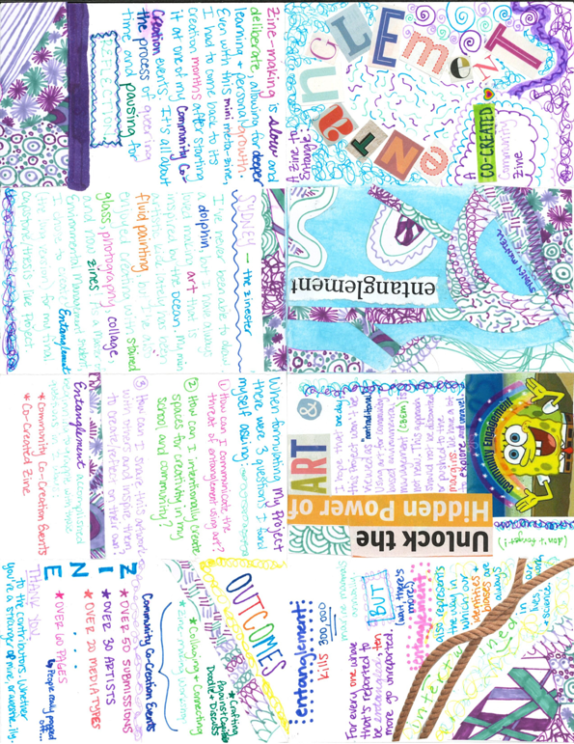
Figure 8. My mini-meta zine reflecting on Entanglement: A Co-Created Community Zine.

Entanglement Zine
While zinemaking was a relatively new practice to me, its roots in Black feminism, environmentalism, and fandoms were the perfect match for me, a Black and Queer fangirl who found themself in an environmental graduate program. The Entanglement zine was created to serve as an archive for the entire process of my MP, including my project inspiration, some of the background research and excerpts from foundational texts, information from the Community Co-Creation events, my own artwork, and creative pieces submitted by others. Over 30 people contributed to Entanglement in various ways, including people who were strangers to me before beginning this MP.
I was inspired by the diversity of the submissions, with over 20 distinct media types appearing in the zine. While some chose to represent physical marine entanglement, many artists interpreted “entanglement” in more abstract ways, such as rejecting white supremacy culture, issues of environmental justice, and grappling with the climate crisis. As mentioned previously, the practice of circulating zines requires trust. Zinesters might feel more comfortable sharing personal reflections and mediations that they might not publish elsewhere. With my own Mammal Project, there are some things I am comfortable sharing here in my Final Report (Figure 9), and others that will only be present in the Entanglement zine.

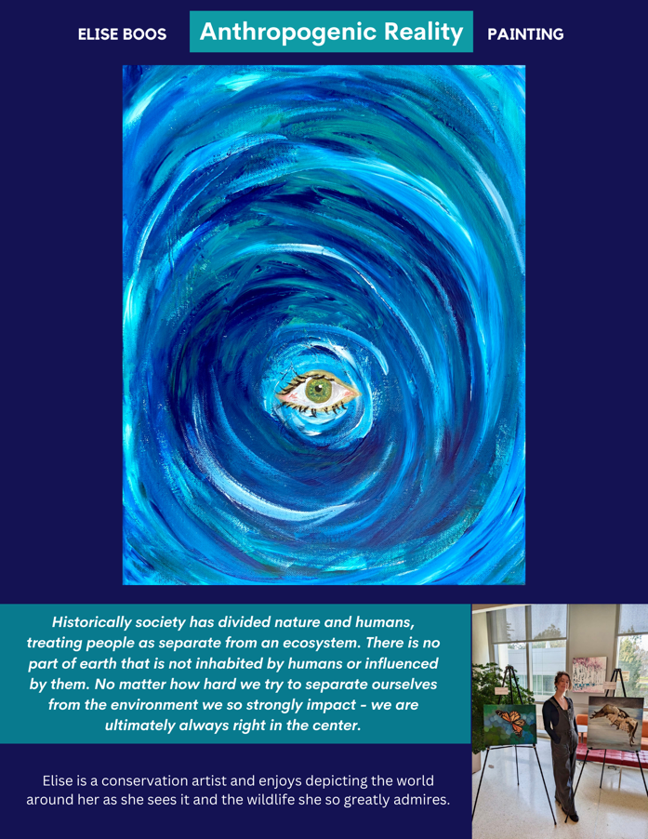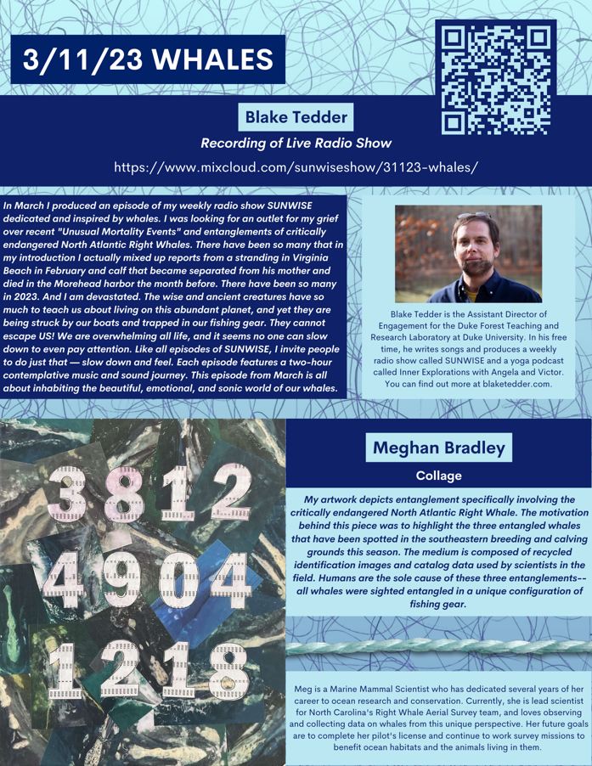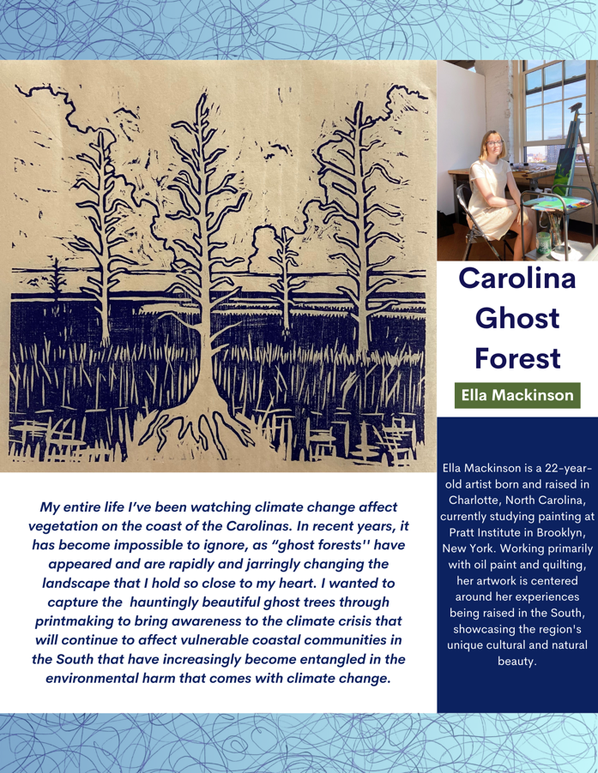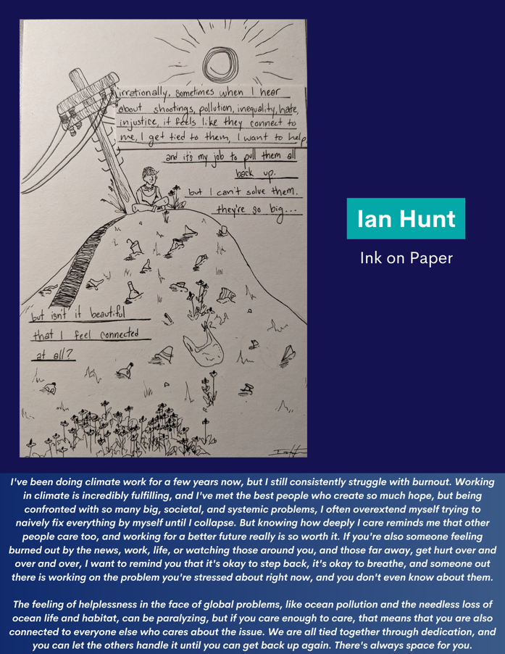
Figure 9. Examples of zine pages from Entanglement.

Ongoing Outcomes

The results of my MP are still being generated, as my creative process remains ongoing. For example, two days after the publication of this report, there will be Entanglement Community Art Exhibition where NSOE community members will be able to view some of the artwork featured in the zine. Attendees may also make their own art by participating in a modified Doodle & Discuss activity. Abridged, 8-page versions of the Entanglement zine will also be distributed during the event. The full-length version will be posted to an online blog where I will be able to share the final product with the artists who contributed and our larger social networks. I also hope to print high-quality versions of Entanglement to send to each of the artists who submitted their work as a token of my gratitude. Collaborating with these artists was the basis for my MP, and I could not have done it without them.
The zinemaking and reflective process will never truly be complete, though. I plan to continue creating and adding new pieces to the online blog where the zine will be hosted in its entirety. Other artists have committed to continue creating and reflecting, as well. For example, my mother, Susan, has made over 140 collages since my “Collaging & Connecting” Community Co-Creation event in November to the publication of this Report in April (Figure 10).

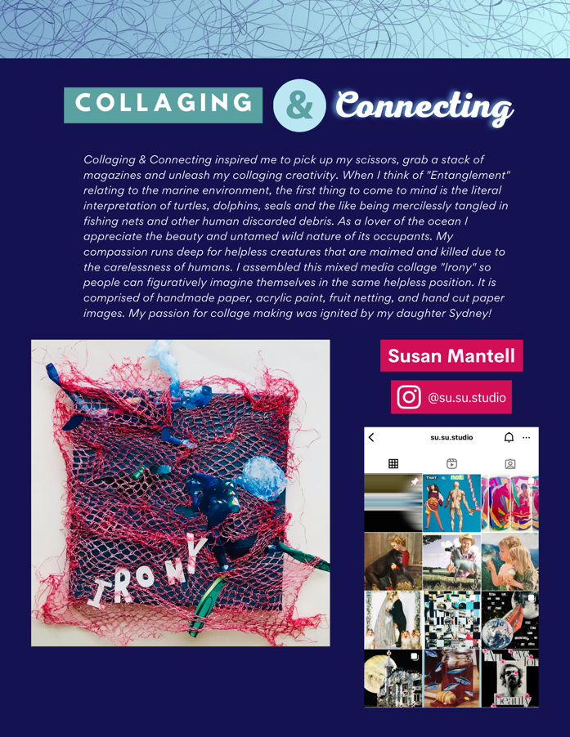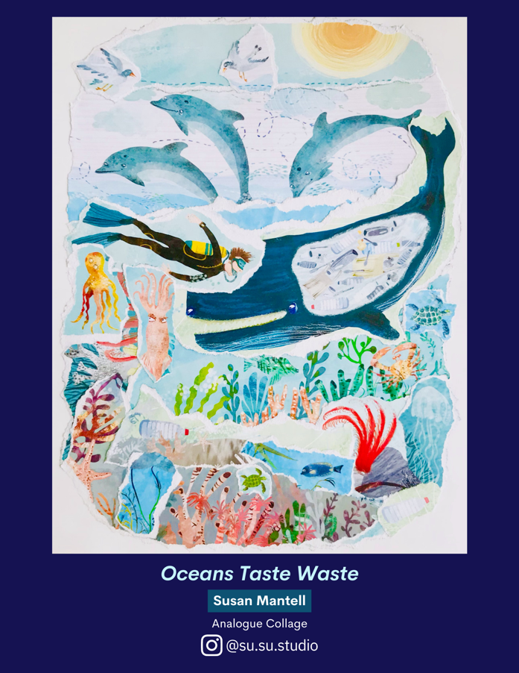
Figure 10. Some of the Entanglement zine pages that showcase my mother’s artwork.

Discussion and Recommendations – it’s your turn

- Read more of Gumbs’s work.
- In addition to Undrowned, Gumbs’s books M Archive: After the End of the World (2018) and Spill: Scenes of Black Feminist Fugitivity (2016) have inspired this MP, as they contain poetic reflection on Black liberation, capitalism, and engaging with another scholars’ work.
- Make a tangle poem.
- At some point during this MP, I created the method of tangle poetry, in which writers let their pens wander, meditating on a certain theme or subject. Jotting down whatever comes to mind in various configurations and shapes and styles embraces fluidity compared to linear poetry styles.
- Bonus points if you incorporate doodling into your tangle poem.
- Check in on a friend.
- Chances are they need it.
- Try fluid painting.
- There are several YouTube channels that explain the process of fluid painting, such as Molly's Artistry, MiiPaintings, and Garrick Brown Art Studio. If you’re not ready to invest in acrylics or a pouring medium, you can also use household materials like craft paints, dish soap, and Elmer’s glue! There are plenty of tutorials online.
- Bake something.
- It’s what Heather Vermeulen would do.
- Watch the “Music for a Sushi Restaurant” music video.
- First, you have to see Harry Styles as a mermaid if you haven’t already.
- Second, the video explores how talent, popularity, and exploitation are entangled within the music industry.
- Learn to resist the oppressive structures and ideals of the neoliberal university.
- Some of the readings I’ve started with (and continue to learn from):
- Ahmed, Sara. On Being Included: Racism and Diversity in Institutional Life. Durham, Duke University Press, 2012.
- Hartman, Saidiya. Venus in Two Acts. Durham, Duke University Press, 2008.
- hooks, bell. Teaching to Transgress: Education as the Practice of Freedom. New York, Routledge, 1994.
- Gumbs, Alexis Pauline. Undrowned: Black Feminist Lessons from Marine Mammals. “thirteen: refuse.” Durham, Duke University Press, 2021.
- Lorde, Audre. A Litany for Survival. In The Black Unicorn: Poems, New York, Norton, 1978.
- Love, Bettina L. We Want to Do More Than Survive: Abolitionist Teaching and the Pursuit of Educational Freedom. Boston, Beacon Press, 2019.
- Reflect on your entanglements. Ask yourself these questions.
- How are my identities, biases, loves, fears, hopes, anxieties, and experiences entangled within my worldview and daily life? How are they entangled in the institutions that I am a part of, like work or school?
- How are the human and nonhuman worlds entangled? Can we ever separate the two? Should we?
- How do we begin to disentangle the conflicting priorities, interests, values, and objectives that cause environmental harm?

Conclusion
My Marine Mammal Apprenticeship continues, despite being at the end of my graduate program, just as it began before I had ever read Undrowned. The lessons came from the fun facts I would find on the Internet in elementary school, scribbling them down in my teal composition notebook. Those marine mammals taught me about curiosity. And the time I saw my first dolphin in the wild, swimming up close to us in Florida. At first, my cousins and I were convinced it was a shark. We only noticed the dorsal fin. That dolphin taught me about what it means to stay hidden until you want to be seen. There’s also my most recent experience with dolphins, near Isla San Pedro Martír in the Gulf of California, when one after another bottlenose would race our boat, leap up in the air, and SPLASH down on all of us. Those dolphins taught me about breaking free. If my Mammal Project has taught me anything, it’s that humans still have a lot to learn.

Works Cited

Ahmed, Sara. “On Being Included: Racism and Diversity in Institutional Life.” International Feminist Journal of Politics 15, no. 2 (June 2013): 290–92. https://doi.org/10.1080/14616742.2013.779142.
Baker, Sarah, and Zelmarie Cantillon. “Zines as Community Archive.” Archival Science 22, no. 4 (December 2022): 539–61. https://doi.org/10.1007/s10502-022-09388-1.
Brown, Autumn, Mairéad Hurley, Sophie Perry, and Joseph Roche. “Zines as Reflective Evaluation Within Interdisciplinary Learning Programmes.” Frontiers in Education 6 (2021). https://www.frontiersin.org/articles/10.3389/feduc.2021.675329.
Caltech Science Exchange. “What Is Entanglement and Why Is It Important?” Accessed April 27, 2023. http://scienceexchange.caltech.edu/topics/quantum-science-explained/entanglement.
Chappell, Bill. “NOAA Halts Whale Disentanglement Efforts After Rescuer Dies.” NPR, July 14, 2017, sec. The Two-Way. https://www.npr.org/sections/thetwo-way/2017/07/14/537271940/noaa-halts-whale-disentanglement-efforts-after-rescuer-dies.
Clark-Parsons, Rosemary. “Feminist Ephemera in a Digital World: Theorizing Zines as Networked Feminist Practice: Feminist Ephemera in a Digital World.” Communication, Culture & Critique 10, no. 4 (December 2017): 557–73. https://doi.org/10.1111/cccr.12172.
“DEI Spotlight – DEI at the Nicholas School.” Accessed April 28, 2023. https://sites.nicholas.duke.edu/diversity/expand-your-knowledge/newsletter/dei-spotlight/.
“Entanglement, n.” In OED Online. Oxford University Press. Accessed April 27, 2023. https://www.oed.com/view/Entry/62785.
“Entanglement Response | The Marine Mammal Center.” Accessed April 28, 2023. https://www.marinemammalcenter.org/science-conservation/conservation/cetacean-conservation/entanglement-response.
Gimeno-Sánchez, Andrea. “Urbanism of Zines: The Potential of Environmentalist Zines as Sources for Planning History.” Planning Perspectives 37, no. 6 (November 2, 2022): 1115–46. https://doi.org/10.1080/02665433.2022.2025887.
Gray, Emily M., Joanna Pollitt, and Mindy Blaise. “Between Activism and Academia: Zine-Making as a Feminist Response to COVID-19.” Gender and Education 34, no. 8 (November 17, 2022): 887–905. https://doi.org/10.1080/09540253.2021.1931045.
Gumbs, Alexis Pauline. M Archive: After the End of the World. Durham ; London: Duke University Press, 2018.
———. Spill: Scenes of Black Feminist Fugitivity. Durham, North Carolina: Duke University Press, 2016.
———. “Undrowned: Black Feminist Lessons from Marine Mammals.” Soundings 78, no. 78 (August 1, 2021): 1–168. https://doi.org/10.3898/SOUN.78.01.2021.
Harry Styles - Music For a Sushi Restaurant (Official Video), 2022. https://www.youtube.com/watch?v=CiwMDFh_Rog.
Hays, Anne. “A Citation Analysis about Scholarship on Zines.” Journal of Librarianship and Scholarly Communication 8, no. 1 (July 23, 2020). https://doi.org/10.7710/2162-3309.2341.
hooks, bell. Teaching to Transgress: Education as the Practice of Freedom. New York: Routledge, 1994.
Jeppesen, Sandra. “DIY Zines and Direct-Action Activism.” Alternative Media in Canada: Policy, Politics and Process, November 24, 2011.
Kühn, Susanne, and Jan Andries Van Franeker. “Quantitative Overview of Marine Debris Ingested by Marine Megafauna.” Marine Pollution Bulletin 151 (February 2020): 110858. https://doi.org/10.1016/j.marpolbul.2019.110858.
Laist, David W. “Impacts of Marine Debris: Entanglement of Marine Life in Marine Debris Including a Comprehensive List of Species with Entanglement and Ingestion Records.” In Marine Debris: Sources, Impacts, and Solutions, edited by James M. Coe and Donald B. Rogers, 99–139. Springer Series on Environmental Management. New York, NY: Springer, 1997. https://doi.org/10.1007/978-1-4613-8486-1_10.
Okun, Tema. “White Supremacy Culture – Still Here,” n.d.
Ramdarshan Bold, Melanie. “Why Diverse Zines Matter: A Case Study of the People of Color Zines Project.” Publishing Research Quarterly 33, no. 3 (September 2017): 215–28. https://doi.org/10.1007/s12109-017-9533-4.
Saini, Angela. “Want to Do Better Science? Admit You’re Not Objective.” Nature 579, no. 7798 (March 9, 2020): 175–175. https://doi.org/10.1038/d41586-020-00669-2.
Velasco, Gabriella, Caroline Faria, and Jayme Walenta. “Imagining Environmental Justice ‘Across the Street’: Zine-Making as Creative Feminist Geographic Method.” GeoHumanities 6, no. 2 (July 2, 2020): 347–70. https://doi.org/10.1080/2373566X.2020.1814161.
Yang, Andrew. “Engaging Participatory Literacy through Science Zines.” The American Biology Teacher 72, no. 9 (November 1, 2010): 573–77. https://doi.org/10.1525/abt.2010.72.9.10.
YouTube. “Garrick Brown Art Studio.” Accessed April 28, 2023. https://www.youtube.com/@GarrickBrownArtStudio.
YouTube. “Mii Paintings.” Accessed April 28, 2023. https://www.youtube.com/@MiiPaintings.
YouTube. “MOLLY’S ARTISTRY.” Accessed April 28, 2023. https://www.youtube.com/@MOLLYSARTISTRY.

Laist, “Impacts of Marine Debris.”
Kühn and Van Franeker, “Quantitative Overview of Marine Debris Ingested by Marine Megafauna.”
“What Is Entanglement and Why Is It Important?”
“Entanglement, n.”
Okun, “White Supremacy Culture – Still Here.”
Gumbs, “Undrowned.”
Gimeno-Sánchez, “Urbanism of Zines.”
Ramdarshan Bold, “Why Diverse Zines Matter.”
Gumbs, “Undrowned.”
Gumbs.
“DEI Spotlight – DEI at the Nicholas School.”
“Entanglement Response | The Marine Mammal Center.”
“Entanglement Response | The Marine Mammal Center.”
Chappell, “NOAA Halts Whale Disentanglement Efforts After Rescuer Dies.”
“What Is Entanglement and Why Is It Important?”
“Entanglement, n.”
Okun, “White Supremacy Culture – Still Here.”
hooks, Teaching to Transgress.
Saini, “Want to Do Better Science?”; Okun, “White Supremacy Culture – Still Here.”
Gray, Pollitt, and Blaise, “Between Activism and Academia.”
Gray, Pollitt, and Blaise.
Ahmed, “On Being Included.”
Gray, Pollitt, and Blaise, “Between Activism and Academia.”
Ahmed, “On Being Included.”
Gray, Pollitt, and Blaise, “Between Activism and Academia.”
Gimeno-Sánchez, “Urbanism of Zines.”
Ramdarshan Bold, “Why Diverse Zines Matter.”
Clark-Parsons, “Feminist Ephemera in a Digital World.”
Velasco, Faria, and Walenta, “Imagining Environmental Justice ‘Across the Street.’”
Jeppesen, “DIY Zines and Direct-Action Activism.”
Brown et al., “Zines as Reflective Evaluation Within Interdisciplinary Learning Programmes.”
Baker and Cantillon, “Zines as Community Archive.”
Velasco, Faria, and Walenta, “Imagining Environmental Justice ‘Across the Street.’”
Hays, “A Citation Analysis about Scholarship on Zines.”
Velasco, Faria, and Walenta, “Imagining Environmental Justice ‘Across the Street.’”
Velasco, Faria, and Walenta; Yang, “Engaging Participatory Literacy through Science Zines.”
Yang, “Engaging Participatory Literacy through Science Zines.”
Yang.
Gray, Pollitt, and Blaise, “Between Activism and Academia.”
Jeppesen, “DIY Zines and Direct-Action Activism.”
Jeppesen.
Clark-Parsons, “Feminist Ephemera in a Digital World.”
Clark-Parsons.
Gumbs, “Undrowned.”
Gumbs, M Archive.
Gumbs, Spill.
“MOLLY’S ARTISTRY.”
“Mii Paintings.”
“Garrick Brown Art Studio.”
Harry Styles - Music For a Sushi Restaurant (Official Video).

